**Database System Final Project Report**

“Quantum Flux - TCG SHOP”



Team Member:

Muhammad Alif Satriadhi 5025221188

Fawwas Aldy Nurramdhan Kaisar 5025221179

Mohmmad Hanif Furqan Aufa Putra 5025221161

Surya Fadli Alamsyah 5025221059

Lecturer:

Ratih Nur Esti Anggraini, S.Kom, M.Sc., Ph.D.

INSTITUT TEKNOLOGI SEPULUH NOPEMBER

SURABAYA

2023/2024

1. Initial Scenario

Given the current boom in Trading Card Games (TCG), an entrepreneur who is also a fan of TCG has decided to open a TCG-themed Game Centre. Recognizing the need for a streamlined transaction process, the entrepreneur has enlisted the services of an acquaintance to design the database system. The Game Centre will offer various card packs from different series (Pokémon, Yu-Gi-Oh, Magic the Gathering, etc.) and feature a card collection display, with some cards available for sale. Additionally, it also offers Game Boards. The owner is a geek, so he is also a veteran player, so he also became a card collector. Therefore, some of the cards owned by the owner are also sold to players. Players can buy/sell/trade cards with the owner's card collection.

The Game Centre also offers a TCG game area where players can play against one another, it also offers a private room if the player doesn't want to wait their turn to play. The private game rooms are divided into three types (Regular, Deluxe, and VIP).  To become a member, the player needs to have provide personal data, including their name and email. The benefits of becoming a member are Access to play in the Game Area, earning points with every transaction, which can be exchanged for merchandise, and Enjoying discounts.

The entrepreneur desires a system that records employee data, including Employee ID, name, gender, phone number, email, and age. Each employee can handle multiple transactions by customers. Customers have the option to purchase more than one item per transaction. Employees will record whether the customer is a member, the total number of items purchased, the total amount due, and the preferred payment method.

The database design aims to facilitate efficient and accurate record-keeping for both employee management and customer transactions, ensuring a seamless experience for all patrons of the TCG-themed Game Centre.

**Assumptions:**

* The Owner is included as the player with a unique ID “OWNER” in CollectionCardTransaction

1. CDM

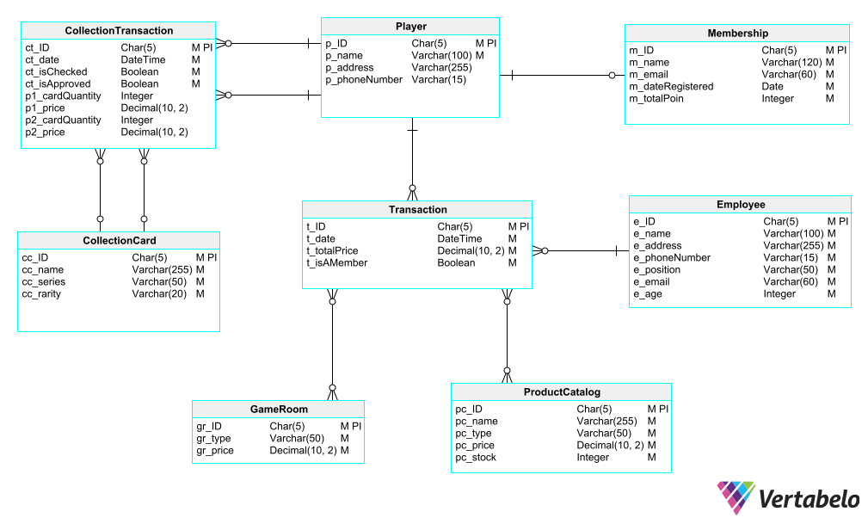

1. PDM

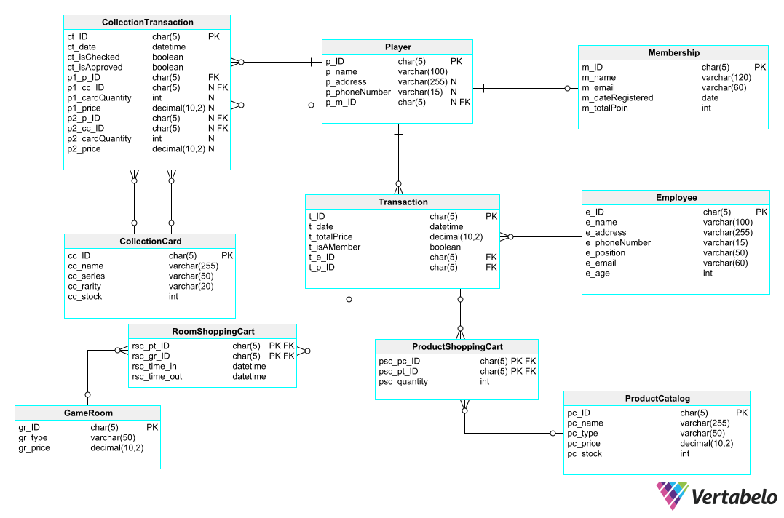

1. DDL

CREATE TABLE CollectionCard (

    cc_ID char(5) NOT NULL,

    cc_name varchar(255) NOT NULL,

    cc_series varchar(50) NOT NULL,

    cc_rarity varchar(20) NOT NULL,

    CONSTRAINT CollectionCard_pk PRIMARY KEY (cc_ID)

);

CREATE TABLE CollectionTransaction (

    ct_ID char(5) NOT NULL,

    ct_date datetime NOT NULL DEFAULT CURRENT_TIMESTAMP,

    ct_isChecked boolean NOT NULL DEFAULT false,

    ct_isApproved boolean NOT NULL DEFAULT false,

    p1_p_ID char(5) NOT NULL,

    p1_cc_ID char(5) NULL,

    p1_cardQuantity int NULL,

    p1_price decimal(10, 2) NULL,

    p2_p_ID char(5) NULL,

    p2_cc_ID char(5) NULL,

    p2_cardQuantity int NULL,

    p2_price decimal(10, 2) NULL,

    CONSTRAINT CollectionTransaction_pk PRIMARY KEY (ct_ID)

);

CREATE TABLE Employee (

    e_ID char(5) NOT NULL,

    e_name varchar(100) NOT NULL,

    e_address varchar(255) NOT NULL,

    e_phoneNumber varchar(15) NOT NULL,

    e_position varchar(50) NOT NULL,

    e_email varchar(60) NOT NULL,

    e_age int NOT NULL,

    CONSTRAINT Employee_pk PRIMARY KEY (e_ID)

);

CREATE TABLE GameRoom (

    gr_ID char(5) NOT NULL,

    gr_type varchar(50) NOT NULL,

    gr_price decimal(10, 2) NOT NULL,

    CONSTRAINT GameRoom_pk PRIMARY KEY (gr_ID)

);

CREATE TABLE Membership (

    m_ID char(5) NOT NULL,

    m_name varchar(120) NOT NULL,

    m_email varchar(60) NOT NULL,

    m_dateRegistered date NOT NULL DEFAULT CURRENT_TIMESTAMP,

    m_totalPoin int NOT NULL DEFAULT 0 CHECK (m_totalPoin >= 0),

    CONSTRAINT Membership_pk PRIMARY KEY (m_ID)

);

CREATE TABLE Player (

    p_ID char(5) NOT NULL,

    p_name varchar(100) NOT NULL,

    p_address varchar(255) NULL,

    p_phoneNumber varchar(15) NULL,

    p_m_ID char(5) NULL,

    CONSTRAINT Player_pk PRIMARY KEY (p_ID)

);

CREATE TABLE ProductCatalog (

    pc_ID char(5) NOT NULL,

    pc_name varchar(255) NOT NULL,

    pc_type varchar(50) NOT NULL,

    pc_price decimal(10, 2) NOT NULL,

    pc_stock int NOT NULL DEFAULT 0 CHECK (pc_stock >= 0),

    CONSTRAINT ProductCatalog_pk PRIMARY KEY (pc_ID)

);

CREATE TABLE ProductShoppingCart (

    psc_pc_ID char(5) NOT NULL,

    psc_pt_ID char(5) NOT NULL,

    psc_quantity int NOT NULL CHECK (psc_quantity >= 0),

    CONSTRAINT ProductCatalog_Transaction_pk PRIMARY KEY (psc_pc_ID, psc_pt_ID)

);

CREATE TABLE RoomShoppingCart (

    rsc_pt_ID char(5) NOT NULL,

    rsc_gr_ID char(5) NOT NULL,

    rsc_time_in datetime NOT NULL DEFAULT CURRENT_TIMESTAMP,

    rsc_time_out datetime NOT NULL DEFAULT (CURRENT_TIMESTAMP + INTERVAL 1 HOUR) CHECK (rsc_time_out > rsc_time_in),

    CONSTRAINT Transaction_GameRoom_pk PRIMARY KEY (rsc_pt_ID, rsc_gr_ID)

);

CREATE TABLE Transaction (

    t_ID char(5) NOT NULL,

    t_date datetime NOT NULL DEFAULT CURRENT_TIMESTAMP,

    t_totalPrice decimal(10, 2) NOT NULL DEFAULT 0 CHECK (t_totalPrice >= 0),

    t_isAMember boolean NOT NULL DEFAULT false,

    t_e_ID char(5) NOT NULL,

    t_p_ID char(5) NOT NULL,

    CONSTRAINT Transaction_pk PRIMARY KEY (t_ID)

);

ALTER TABLE

    CollectionTransaction

ADD

    CONSTRAINT CollectionCard_CollectionTransaction_P1 FOREIGN KEY CollectionCard_CollectionTransaction_P1 (p1_cc_ID) REFERENCES CollectionCard (cc_ID);

ALTER TABLE

    CollectionTransaction

ADD

    CONSTRAINT CollectionTransaction_CollectionCard_P2 FOREIGN KEY CollectionTransaction_CollectionCard_P2 (p2_cc_ID) REFERENCES CollectionCard (cc_ID);

ALTER TABLE

    CollectionTransaction

ADD

    CONSTRAINT CollectionTransaction_Player_P1 FOREIGN KEY CollectionTransaction_Player_P1 (p1_p_ID) REFERENCES Player (p_ID);

ALTER TABLE

    CollectionTransaction

ADD

    CONSTRAINT CollectionTransaction_Player_P2 FOREIGN KEY CollectionTransaction_Player_P2 (p2_p_ID) REFERENCES Player (p_ID);

ALTER TABLE

    Player

ADD

    CONSTRAINT Player_Membership FOREIGN KEY Player_Membership (p_m_ID) REFERENCES Membership (m_ID);

ALTER TABLE

    ProductShoppingCart

ADD

    CONSTRAINT ProductCatalog_Transaction_ProductCatalog FOREIGN KEY ProductCatalog_Transaction_ProductCatalog (psc_pc_ID) REFERENCES ProductCatalog (pc_ID);

ALTER TABLE

    ProductShoppingCart

ADD

    CONSTRAINT ProductCatalog_Transaction_Transaction FOREIGN KEY ProductCatalog_Transaction_Transaction (psc_pt_ID) REFERENCES Transaction (t_ID);

ALTER TABLE

    Transaction

ADD

    CONSTRAINT ProductTransaction_Employee FOREIGN KEY ProductTransaction_Employee (t_e_ID) REFERENCES Employee (e_ID);

ALTER TABLE

    Transaction

ADD

    CONSTRAINT ProductTransaction_Player FOREIGN KEY ProductTransaction_Player (t_p_ID) REFERENCES Player (p_ID);

ALTER TABLE

    RoomShoppingCart

ADD

    CONSTRAINT Transaction_GameRoom_GameRoom FOREIGN KEY Transaction_GameRoom_GameRoom (rsc_gr_ID) REFERENCES GameRoom (gr_ID);

ALTER TABLE

    RoomShoppingCart

ADD

    CONSTRAINT Transaction_GameRoom_Transaction FOREIGN KEY Transaction_GameRoom_Transaction (rsc_pt_ID) REFERENCES Transaction (t_ID);

Result:

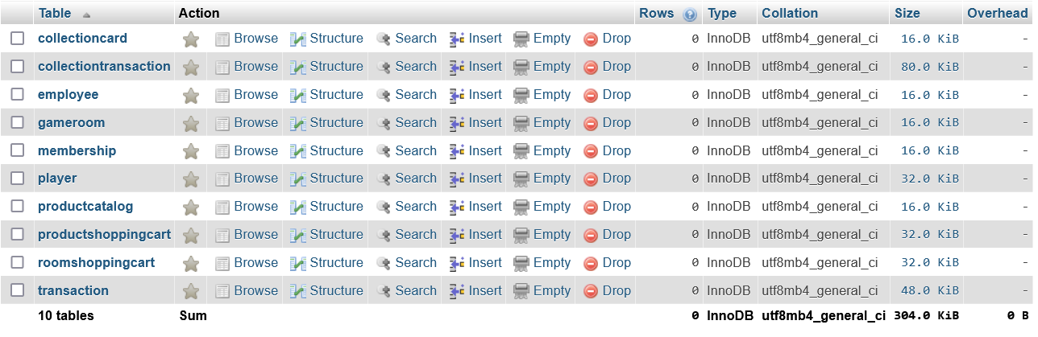

The DML will be divided into 2 parts namely november and december parts followed by a query per part after the dml, this will allow a more realistic experience in operating the database.

5a. November’s DML

*-- Employee table*

INSERT INTO Employee (e_ID, e_name, e_address, e_phoneNumber, e_position, e_email, e_age) VALUES

('E0001', 'Xiao Yuu', 'Jl. Jenderal Sudirman No. 123', '555-1111', 'Owner', 'xiaoyuu@gmail.com', 29),

('E0002', 'Hakken Ryou', 'Jl. Thamrin No. 456', '555-2222', 'Cashier', 'hakken@yahoo.com', 25),

('E0003', 'Ronan Loch', 'Jl. Hayam Wuruk No. 789', '555-3333', 'Game Room Assistant', 'ronan@outlook.com', 24),

('E0004', 'Adam Stewart', 'Jl. Kebon Sirih No. 101', '555-4444', 'Janitor', 'adam@yahoo.com', 26),

('E0005', 'David Wicaksono', 'Jl. MH. Thamrin No. 202', '555-5555', 'Janitor', 'davidw@gmail.com', 25);

Result:

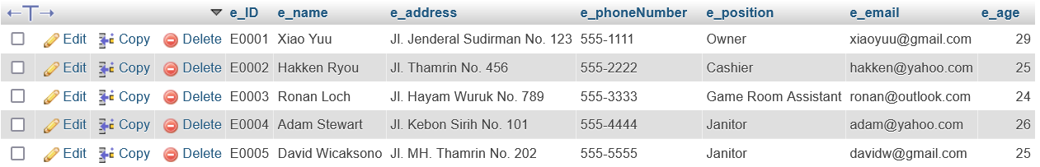

*-- ProductCatalog table*

INSERT INTO ProductCatalog (pc_ID, pc_name, pc_type, pc_price, pc_stock) VALUES

('PC001', 'Vivid Voltage Booster Pack', 'Pokemon Booster Pack', 55000, 20),

('PC002', 'Scarlet & Violet Booster Pack', 'Pokemon Booster Pack', 65000, 10),

('PC003', 'Sword & Shield Booster Pack', 'Pokemon Booster Pack', 45000, 15),

('PC004', 'Brave Destroyer Booster Pack', 'Yu GI Oh Booster Pack', 50000, 15),

('PC005', 'Legendary Duel: Soul-Burning Volcano Booster Pack', 'Yu GI Oh Booster Pack', 70000, 5),

('PC006', 'Draft Booster', 'Magic: The Gathering Booster Pack', 60000, 10),

('PC007', 'Jumpstart Booster', 'Magic: The Gathering Booster Pack', 55000, 20);

Result:

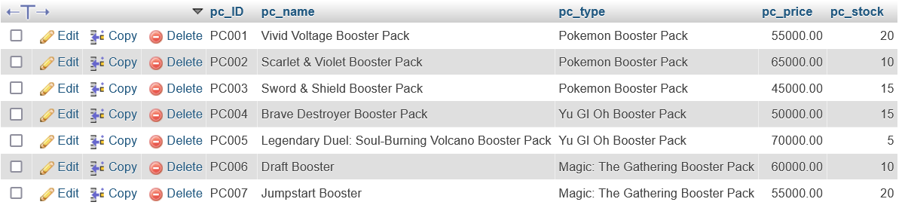

*-- GameRoom table*

INSERT INTO GameRoom (gr_ID, gr_type, gr_price) VALUES

('GR001', 'Reguler', 20000.00),

('GR002', 'Deluxe', 40000.00),

('GR003', 'VIP', 50000.00);

Result:

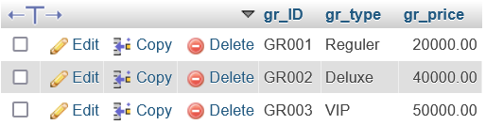

*-- Membership table*

INSERT INTO Membership (m_ID, m_name, m_email, m_dateRegistered, m_totalPoin) VALUES

('OWNER', 'Master Rusdi', 'rusdi@gmail.com', '2023-01-01', 1000),

('M0001', 'Oda', 'oda@gmail.com', '2023-01-01', 100),

('M0002', 'Arsene', 'arsene@hotmail.com', '2023-02-15', 150),

('M0003', 'Rozen', 'rozen@yahoo.com', '2023-03-30', 200),

('M0004', 'Flan', 'flan@gmail.com', '2023-04-10', 120),

('M0005', 'Fyodor', 'fyodor@rocketmail.com', '2023-05-22', 180),

('M0006', 'Salvanse', 'salvanse@hotmail.com', '2023-06-05', 220),

('M0007', 'Cyanstar', 'lordk@gmail.com', '2023-07-15', 90);

Result:

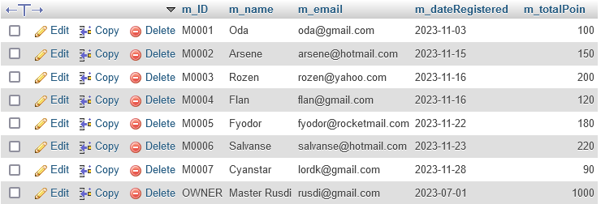

In this data, Player Kang Ryu hasn’t registered as a member

*-- Player table*

INSERT INTO Player (p_ID, p_m_ID, p_name, p_address, p_phoneNumber) VALUES

('OWNER', 'OWNER', 'Rusdi', 'Jl. semangka', '111-111'),

('P0001', 'M0001', 'Teja Hoshizora', 'Jl. Merdeka No. 123', '555-1234'),

('P0002', 'M0002', 'Leo Leon', 'Jl. Kebon Sirih No. 456', '555-5678'),

('P0003', 'M0003', 'Alif Satria', 'Jl. Sudirman No. 789', '555-9012'),

('P0004', 'M0004', 'Rafli Rai', 'Jl. Pangeran Antasari No. 101', '555-3456'),

('P0005', 'M0005', 'Moris Idris', 'Jl. Gatot Subroto No. 202', '555-7890'),

('P0006', 'M0006', 'Hanif Kan', 'Jl. Thamrin No. 303', '555-1234'),

('P0007', 'M0007', 'Lord Kaisar', 'Jl. Hayam Wuruk No. 404', '555-5678'),

('P0008', NULL, 'Kang Ryu', 'Jl. Wahid Hasyim No. 505', '555-9012');

Result:

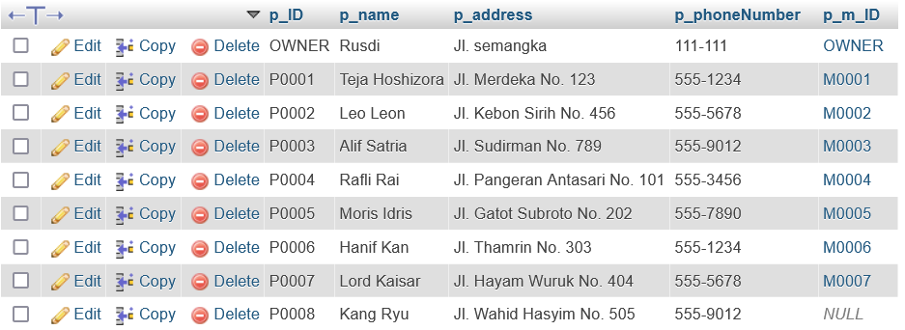

*-- CollectionCard table*

INSERT INTO CollectionCard (cc_ID, cc_name, cc_series, cc_rarity) VALUES

('CC001', 'Pikachu', 'Pokemon', 'Common'),

('CC002', 'Charizard', 'Pokemon', 'Rare'),

('CC003', 'Blastoise', 'Pokemon', 'Rare'),

('CC004', 'Dark Magician', 'Yu GI Oh', 'Ultra Rare'),

('CC005', 'Blue-Eyes White Dragon', 'Yu GI Oh', 'Ultra Rare'),

('CC006', 'Exodia the Forbidden One', 'Yu GI Oh', 'Secret Rare'),

('CC007', 'Jace, the Mind Sculptor', 'Magic: The Gathering', 'Mythic Rare'),

('CC008', 'Black Lotus', 'Magic: The Gathering', 'Mythic Rare'),

('CC009', 'Serra Angel', 'Magic: The Gathering', 'Rare'),

('CC010', 'Mewtwo', 'Pokemon', 'Legendary Rare'),

('CC011', 'Red-Eyes Black Dragon', 'Yu GI Oh', 'Super Rare'),

('CC012', 'Gyarados', 'Pokemon', 'Rare'),

('CC013', 'Force of Will', 'Magic: The Gathering', 'Rare'),

('CC014', 'Zygarde', 'Pokemon', 'Rare'),

('CC015', 'Raigeki', 'Yu GI Oh', 'Super Rare');

Result:

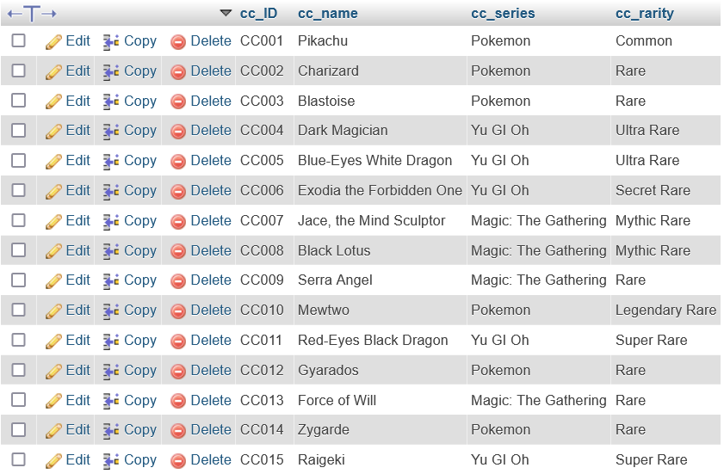

*-- Transaction table*

INSERT INTO Transaction (t_ID, t_date, t_totalPrice, t_isAMember, t_e_ID, t_p_ID) VALUES

('T0001', '2023-11-01 12:30:00', 0.00, 1, 'E0001', 'P0001'),

('T0002', '2023-11-02 14:45:00', 0.00, 1, 'E0002', 'P0002'),

('T0003', '2023-11-03 10:15:00', 0.00, 1, 'E0003', 'P0003'),

('T0004', '2023-11-04 16:00:00', 0.00, 1, 'E0004', 'P0004'),

('T0005', '2023-11-05 11:30:00', 0.00, 1, 'E0005', 'P0005');

Result:

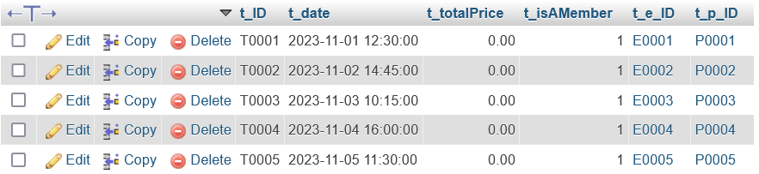

*-- ProductShoppingCart table*

INSERT INTO ProductShoppingCart (psc_pc_ID, psc_pt_ID, psc_quantity) VALUES

('PC002', 'T0001', 2),

('PC004', 'T0001', 1),

('PC005', 'T0002', 3),

('PC007', 'T0002', 1),

('PC003', 'T0003', 2),

('PC006', 'T0003', 1),

('PC002', 'T0004', 3),

('PC005', 'T0004', 2),

('PC004', 'T0005', 1),

('PC006', 'T0005', 2);

Result:

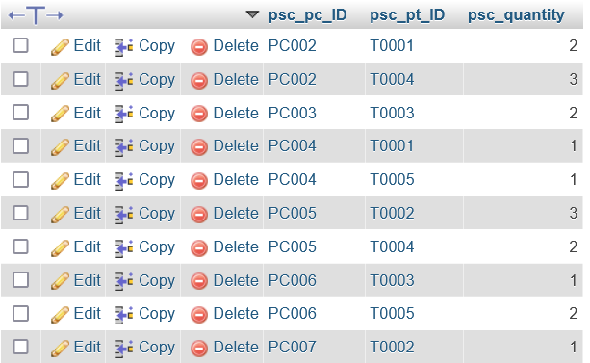

*-- RoomShoppingCart table*

INSERT INTO RoomShoppingCart (rsc_pt_ID, rsc_gr_ID, rsc_time_in, rsc_time_out) VALUES

('T0001', 'GR001', '2023-11-01 12:30:00', '2023-11-01 15:30:00'),

('T0002', 'GR002', '2023-11-02 14:45:00', '2023-11-02 17:45:00'),

('T0003', 'GR003', '2023-11-03 10:15:00', '2023-11-03 12:15:00'),

('T0004', 'GR001', '2023-11-04 16:00:00', '2023-11-04 19:00:00'),

('T0005', 'GR002', '2023-11-05 11:30:00', '2023-11-05 14:30:00');

Result:

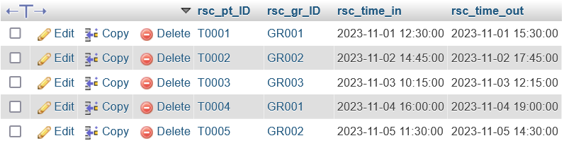

*-- update transaction*

UPDATE Transaction

SET t_totalPrice = (

    SELECT SUM(pc_price * psc_quantity)

    FROM ProductShoppingCart

    JOIN ProductCatalog ON ProductShoppingCart.psc_pc_ID = ProductCatalog.pc_ID

    WHERE ProductShoppingCart.psc_pt_ID = Transaction.t_ID

) + (

    SELECT SUM(gr_price * TIMESTAMPDIFF(SECOND, rsc_time_in, rsc_time_out) / 3600)

    FROM RoomShoppingCart

    JOIN GameRoom ON RoomShoppingCart.rsc_gr_ID = GameRoom.gr_ID

    WHERE RoomShoppingCart.rsc_pt_ID = Transaction.t_ID

)

Result:

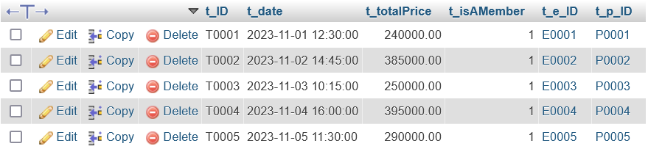

*-- CollectionTransaction table*

INSERT INTO CollectionTransaction

(ct_ID, ct_date, ct_isChecked, ct_isApproved, p1_p_ID, p1_cc_ID, p1_cardQuantity, p1_price, p2_p_ID, p2_cc_ID, p2_cardQuantity, p2_price) VALUES

('CT001', '2023-12-10 14:00:00', false, false, 'P0002', 'CC001', 1, 10000.00, NULL, NULL, NULL, NULL),

('CT002', '2023-12-15 16:30:00', false, false, 'OWNER', 'CC002', 1, NULL, NULL, NULL, NULL, NULL);

Result:



*-- Update for the first transaction (P1 Buying P2 card) & (Trading from P1 with P2 card but rejected)*

UPDATE CollectionTransaction

SET p2_p_ID = 'P0001'

WHERE ct_ID = 'CT001';

UPDATE CollectionTransaction

SET p2_p_ID = 'P0003', p2_cc_ID = 'CC004', p2_cardQuantity = 1

WHERE ct_ID = 'CT002';

Result:



*-- Update for the confirmation for each transaction*

UPDATE CollectionTransaction

SET ct_isChecked = true,

    ct_isApproved = true

WHERE ct_ID = 'CT001';

UPDATE CollectionTransaction

SET ct_isChecked = true,

    ct_isApproved = false,

    p2_p_ID = NULL,

    p2_cc_ID = NULL,

    p2_cardQuantity = NULL

WHERE ct_ID = 'CT002';

Result:



6a. November’s Query

*-- Basic Query*

*-- 1 Tampilkan nama player dan memebrship point sort descending (sort)*

SELECT

    Player.p_name AS PlayerName,

    Membership.m_name AS MemberName,

    Membership.m_totalPoin AS MembershipPoints

FROM

    Player

JOIN

    Membership ON Player.p_m_ID = Membership.m_ID

ORDER BY

    Membership.m_totalPoin DESC;

Result:

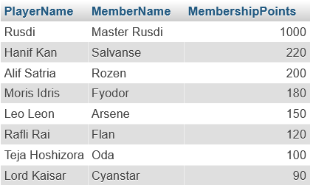

*-- 2 Tampilkan informasi transaksi koleksi kartu yang berkaitan dengan owner (filter)*

SELECT ct.*, cc.*,p.p_name

FROM collectiontransaction ct

JOIN collectioncard cc ON ct.p1_cc_ID = cc.cc_ID

JOIN player p ON ct.p1_p_ID = p_id

WHERE ct.p1_p_ID = 'OWNER';

Result:

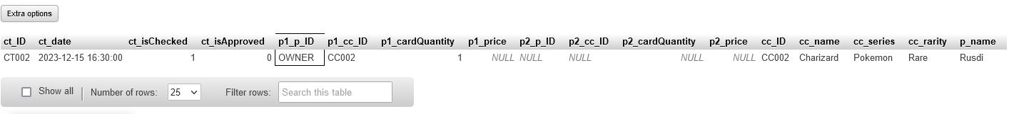

*-- 3 Find most expensive product*

SELECT

    pc_name AS MostExpensiveProduct,

    pc_price AS MaxPrice

FROM

    ProductCatalog

ORDER BY

    pc_price DESC

LIMIT 1;

Result:

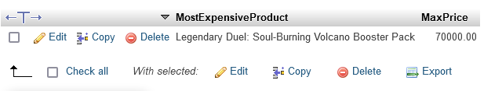

*-- 4 Show collection card, group by rarity*

SELECT

    cc_rarity AS Rarity,

    GROUP_CONCAT(cc_name SEPARATOR '; ') AS CollectionCardNames

FROM

    CollectionCard

GROUP BY

    cc_rarity;

Result:

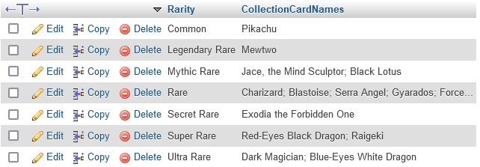

*-- 5 To display employees whose email addresses do not use Gmai*

SELECT *

FROM employee

WHERE NOT e_email LIKE '%@gmail.com%';

Result:

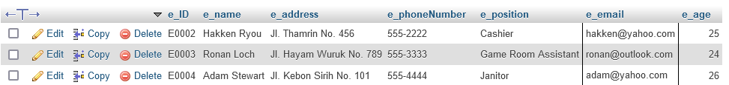

*-- Aggregate Query*

*-- 1 Get number of transactions made by each player*

SELECT p.p_ID AS player_id, p.p_name AS player_name, COUNT(*) AS transaction_count

FROM player p

JOIN transaction t ON p.p_ID = t.t_p_ID

GROUP BY p.p_ID, p.p_name;

Result:

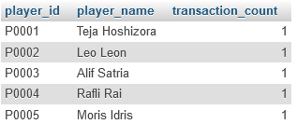

*-- 2 Get  the total revenue generated from each game room type*

SELECT

    gr.gr_ID,

    gr.gr_type,

    SUM(tr.t_totalPrice) AS total_revenue,

    COUNT(tr.t_ID) AS total_transactions

FROM

    gameroom gr

LEFT JOIN

    roomshoppingcart rsc ON gr.gr_ID = rsc.rsc_gr_ID

LEFT JOIN

    transaction tr ON rsc.rsc_pt_ID = tr.t_ID

GROUP BY

    gr.gr_ID, gr.gr_type

ORDER BY

    total_revenue DESC;

Result:

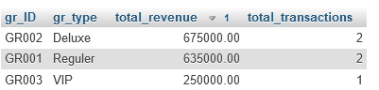

*-- 3 List total number of transactions, the average transaction amount, and the player with the highest total, except owner*

SELECT

    player.p_ID,

    player.p_name,

    COUNT(transaction.t_ID) AS total_transactions,

    AVG(transaction.t_totalPrice) AS average_transaction_amount,

    MAX(transaction.t_totalPrice) AS highest_transaction_amount

FROM

    player

LEFT JOIN

    transaction ON player.p_ID = transaction.t_p_ID

WHERE

    player.p_ID <> 'OWNER'

GROUP BY

    player.p_ID, player.p_name

ORDER BY

    highest_transaction_amount DESC;

Result:

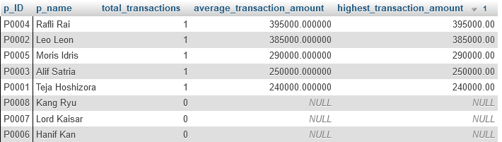

*-- 4 Total pendapatan bulan november*

SELECT SUM(t_totalPrice) AS totalPendapatan FROM Transaction;

Result:



*-- Nested Query*

*-- 1 Display products that have been sold more than the average quantity sold*

SELECT

    pc.pc_ID,

    pc.pc_name,

    pc.pc_type,

    pc.pc_price,

    SUM(psc.psc_quantity) AS total_sold

FROM

    productcatalog pc

JOIN

    productshoppingcart psc ON pc.pc_ID = psc.psc_pc_ID

JOIN

    transaction t ON psc.psc_pt_ID = t.t_ID

GROUP BY

    pc.pc_ID

HAVING

    total_sold > (SELECT AVG(psc_quantity) FROM productshoppingcart);

Result:

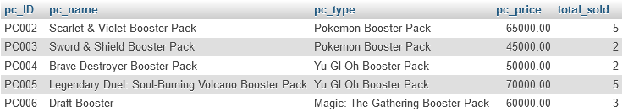

*-- 2 Display the employee name and the total transaction for each employee*

SELECT

    e.e_name,

    (

        SELECT COUNT(t_ID)

        FROM Transaction

        WHERE t_e_ID = e.e_ID

    ) AS total_transactions

FROM

    Employee e;

Result:

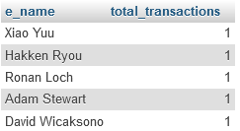

*-- 3 Search for the player that bought the most expensive product*

SELECT

    t.t_ID,

    p.p_name AS player_name,

    (

        SELECT pc_name

        FROM ProductCatalog pc

        WHERE pc.pc_ID = (

            SELECT psc_pc_ID

            FROM ProductShoppingCart

            WHERE psc_pt_ID = t.t_ID

            ORDER BY (SELECT pc_price FROM ProductCatalog WHERE pc_ID = psc_pc_ID) DESC

            LIMIT 1

        )

    ) AS most_expensive_product,

    (

        SELECT MAX((SELECT pc_price FROM ProductCatalog WHERE pc_ID = psc_pc_ID) * psc_quantity)

        FROM ProductShoppingCart

        WHERE psc_pt_ID = t.t_ID

    ) AS total_spent

FROM

    Transaction t

    JOIN Player p ON t.t_p_ID = p.p_ID

ORDER BY total_spent DESC

LIMIT 1;

Result:



5b. December’s DML

*-- Player Ryu Liam came and brought his friends, then registered for membership.*

INSERT INTO Membership (m_ID, m_name, m_email, m_dateRegistered, m_totalPoin) VALUES

('M0008', 'Topazr', 'topaz@yahoo.com', '2023-08-28', 130);

INSERT INTO Player (p_ID, p_m_ID, p_name, p_address, p_phoneNumber) VALUES

('P0009', NULL, 'Ian Harris', 'Jl. Diponegoro No. 606', '555-3456'),

('P0010', NULL, 'Julia Clark', 'Jl. HR. Rasuna Said No. 707', '555-7890');

INSERT INTO Membership (m_ID, m_name, m_email, m_dateRegistered, m_totalPoin) VALUES

('M0009', 'Vanila', 'vanila@hotmail.com', '2023-09-09', 170),

('M0010', 'Tiramisu', 'tiramisu@gmail.com', '2023-10-20', 210);

Result:

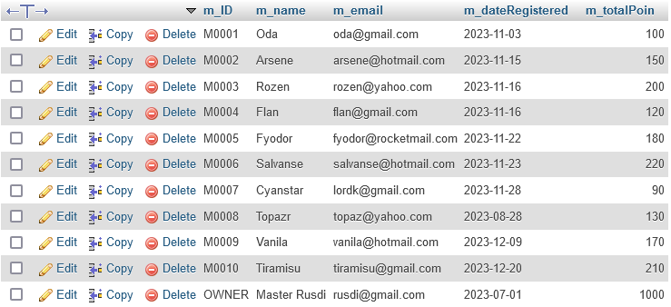

UPDATE Player

SET p_m_ID = 'M0008'

WHERE p_ID = 'P0008';

UPDATE Player

SET p_m_ID = 'M0009'

WHERE p_ID = 'P0009';

UPDATE Player

SET p_m_ID = 'M0010'

WHERE p_ID = 'P0010';

Result:

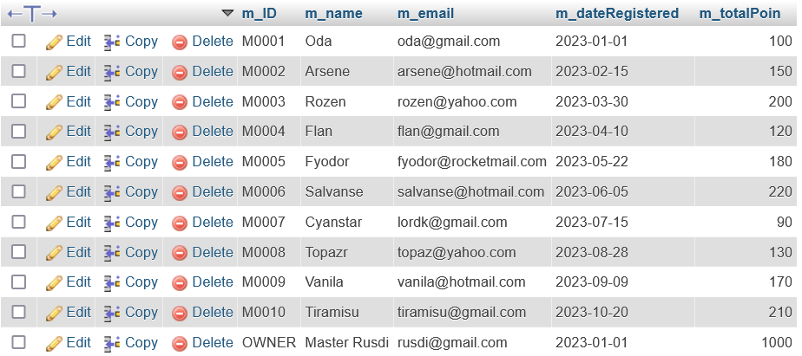

*-- New Product: Card Deck Launch*

INSERT INTO ProductCatalog (pc_ID, pc_name, pc_type, pc_price, pc_stock) VALUES

('PC008', 'Mew Genesect', 'Pokemon Deck', 110000, 3),

('PC009', 'Inteleon Urshifu', 'Pokemon Deck', 130000, 5);

INSERT INTO ProductCatalog (pc_ID, pc_name, pc_type, pc_price, pc_stock) VALUES

('PC010', 'Salamangreat', 'Yu GI Oh Deck', 120000, 1),

('PC011', 'Mannadium Scareclaw Kashtira', 'Yu GI Oh Deck', 135000, 2);

INSERT INTO ProductCatalog (pc_ID, pc_name, pc_type, pc_price, pc_stock) VALUES

('PC012', 'Vintage', 'Magic: The Gathering Deck', 100000, 5),

('PC013', 'Alchemy', 'Magic: The Gathering Deck', 110000, 2);

Result:

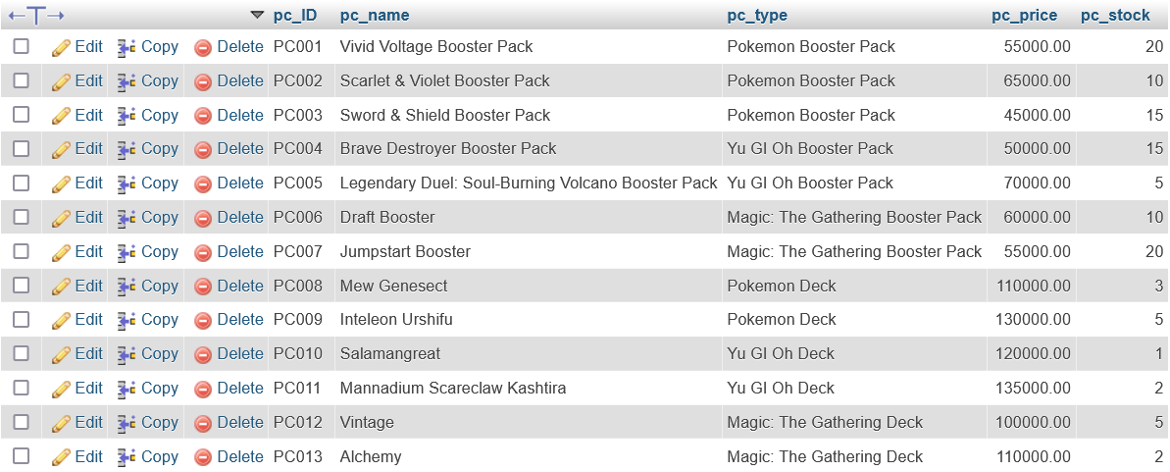

*-- New Product: Merchandise Launch*

INSERT INTO ProductCatalog (pc_ID, pc_name, pc_type, pc_price, pc_stock) VALUES

('PC014', 'Pokemon Hat', 'Type Merchandise', 130000, 3),

('PC015', 'Yu Gi Oh Prism', 'Type Merchandise', 150000, 3),

('PC016', 'Planeswalker Hat', 'Type Merchandise', 110000, 3),

('PC017', 'Pokemon Play Game Sheet', 'Type Merchandise', 35000, 10),

('PC018', 'Yu Gi Oh Play Game Sheet', 'Type Merchandise', 45000, 10),

('PC019', 'Magic: The Gathering Play Game Sheet', 'Type Merchandise', 40000, 10);

Result:

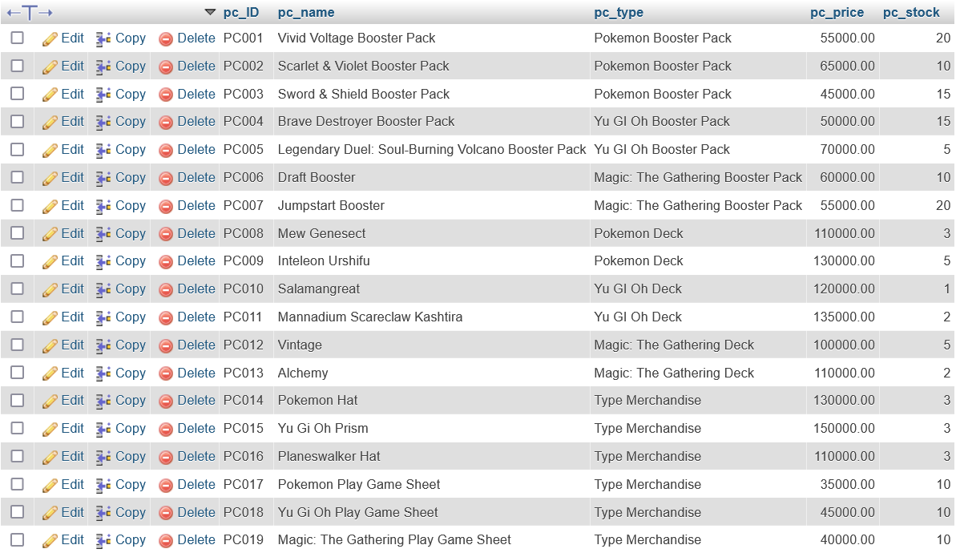

*-- Update Stock and replacing Product*

UPDATE ProductCatalog

SET pc_stock = 10

WHERE pc_type LIKE '%Booster Pack%' AND pc_name <> 'Salamangreat';

UPDATE ProductCatalog

SET pc_name = 'Infemobile Sinfulness', pc_price = 110000, pc_stock = 5

WHERE pc_ID = 'PC010';

Result:

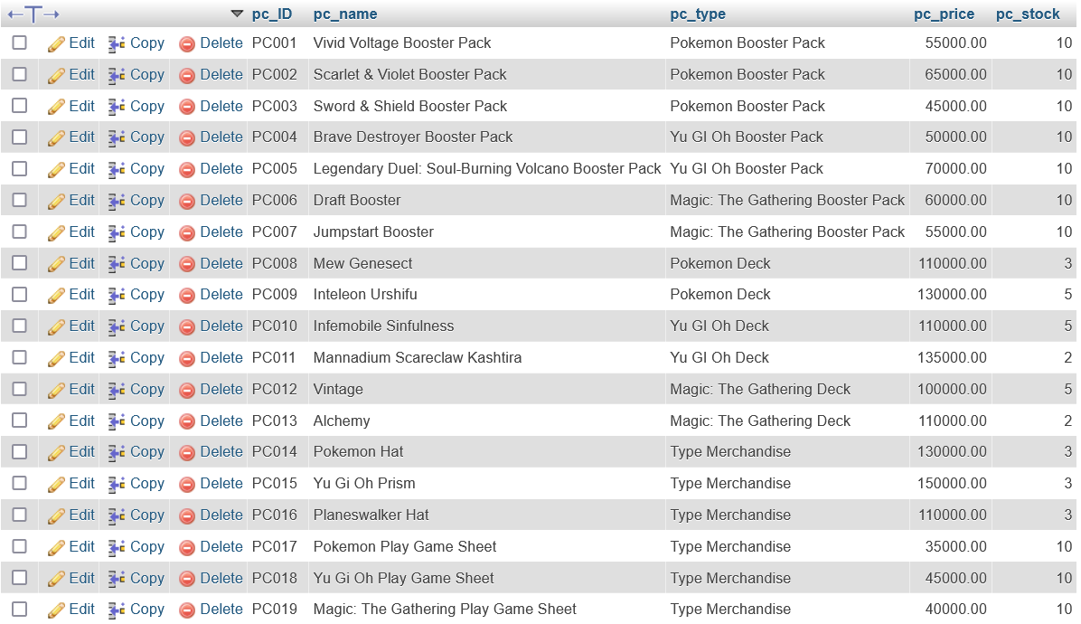

*-- transaction in December*

*-- Transaction table*

INSERT INTO Transaction (t_ID, t_date, t_totalPrice, t_isAMember, t_e_ID, t_p_ID) VALUES

('T0006', '2023-12-01 10:00:00', 0.00, 1, 'E0001', 'P0008'),

('T0007', '2023-12-02 13:45:00', 0.00, 1, 'E0002', 'P0009'),

('T0008', '2023-12-03 11:15:00', 0.00, 1, 'E0003', 'P0010'),

('T0009', '2023-12-04 14:00:00', 0.00, 1, 'E0004', 'P0001'),

('T0010', '2023-12-05 12:30:00', 0.00, 1, 'E0005', 'P0002');

Result:

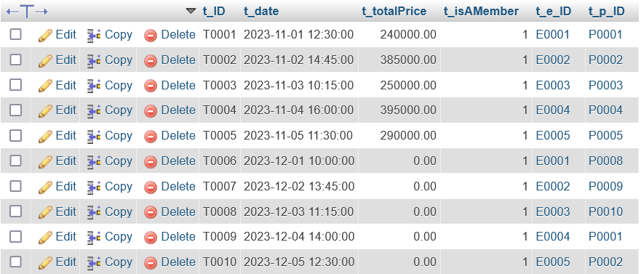

*-- ProductShoppingCart table*

    INSERT INTO ProductShoppingCart (psc_pc_ID, psc_pt_ID, psc_quantity) VALUES

    ('PC008', 'T0006', 2),

    ('PC014', 'T0006', 1),

    ('PC009', 'T0007', 3),

    ('PC016', 'T0007', 1),

    ('PC011', 'T0008', 2),

    ('PC013', 'T0008', 1),

    ('PC010', 'T0009', 3),

    ('PC015', 'T0009', 2),

    ('PC012', 'T0010', 1),

    ('PC017', 'T0010', 2);

Result:

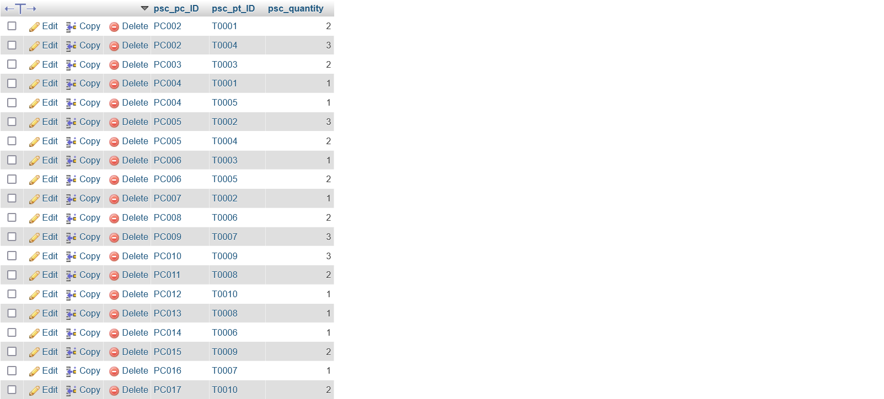

*-- RoomShoppingCart table*

    INSERT INTO RoomShoppingCart (rsc_pt_ID, rsc_gr_ID, rsc_time_in, rsc_time_out) VALUES

    ('T0006', 'GR001', '2023-12-01 10:00:00', '2023-12-01 13:00:00'),

    ('T0007', 'GR002', '2023-12-02 13:45:00', '2023-12-02 16:45:00'),

    ('T0008', 'GR003', '2023-12-03 11:15:00', '2023-12-03 13:15:00'),

    ('T0009', 'GR001', '2023-12-04 14:00:00', '2023-12-04 17:00:00'),

    ('T0010', 'GR002', '2023-12-05 12:30:00', '2023-12-05 15:30:00');

Result:

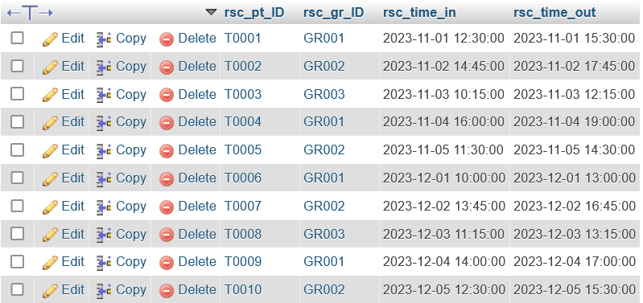

*-- Update transaction*

    UPDATE Transaction

    SET t_totalPrice = (

    SELECT SUM(pc_price * psc_quantity)

    FROM ProductShoppingCart

    JOIN ProductCatalog ON ProductShoppingCart.psc_pc_ID = ProductCatalog.pc_ID

    WHERE ProductShoppingCart.psc_pt_ID = Transaction.t_ID

    ) + (

    SELECT SUM(gr_price * TIMESTAMPDIFF(SECOND, rsc_time_in, rsc_time_out) / 3600)

    FROM RoomShoppingCart

    JOIN GameRoom ON RoomShoppingCart.rsc_gr_ID = GameRoom.gr_ID

    WHERE RoomShoppingCart.rsc_pt_ID = Transaction.t_ID

    )

    WHERE t_totalPrice = 0;

Result:

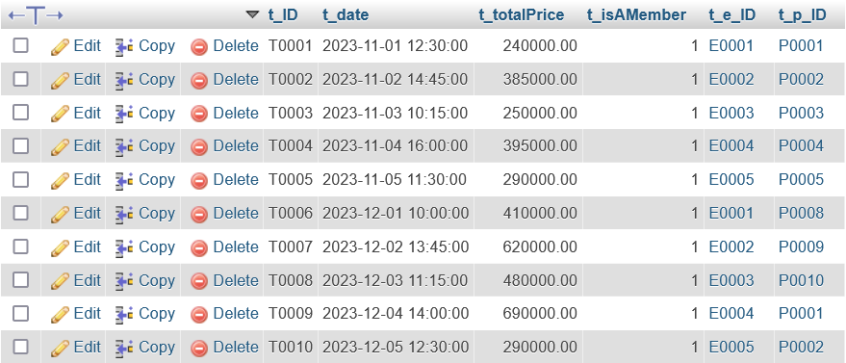

6b. December’s Query

*-- Basic Query*

*-- 1 Show approved collection transactions*

SELECT ct.ct_ID, ct.ct_date, p1.p_name AS player1, p2.p_name AS player2

FROM collectiontransaction ct

JOIN player p1 ON ct.p1_p_ID = p1.p_ID

JOIN player p2 ON ct.p2_p_ID = p2.p_ID

WHERE ct.ct_isApproved = 1;

Result:



*-- 2 Show the least used game room*

SELECT gr.gr_ID, gr.gr_type, COUNT(rsc.rsc_gr_ID) AS usage_count

FROM gameroom gr

JOIN roomshoppingcart rsc ON gr.gr_ID = rsc.rsc_gr_ID

GROUP BY gr.gr_ID, gr.gr_type

ORDER BY usage_count ASC

LIMIT 1;

Result:



*-- 3 Show all transactions in December*

SELECT *

FROM transaction

WHERE MONTH(t_date) = 12;

Result:

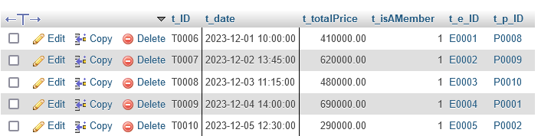

*-- 4 Member created in december*

SELECT *

FROM membership

WHERE MONTH(m_dateRegistered) = 12;

Result:

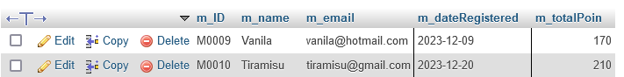

*-- 5 Retrieve employee names and contact information*

SELECT

    e_name,

    e_phoneNumber,

    e_email

FROM

    `employee`

WHERE

    e_age > 24;

Result:

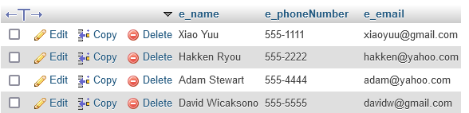

*-- Aggregate Query*

*-- 1 Find the top 3 players who spent the most money on transactions in December*

SELECT p.p_name, SUM(t.t_totalPrice) AS total_spent

FROM player p

JOIN transaction t ON p.p_ID = t.t_p_ID

WHERE MONTH(t.t_date) = 12

GROUP BY p.p_name

ORDER BY total_spent DESC

LIMIT 3;

Result:

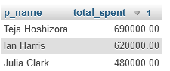

*-- 2 Show the most used game room by time*

SELECT gr.gr_ID, gr.gr_type, SUM(TIMESTAMPDIFF(SECOND, rsc.rsc_time_in, rsc.rsc_time_out)) AS second_spent

FROM GameRoom gr

JOIN RoomShoppingCart rsc ON gr.gr_ID = rsc.rsc_gr_ID

GROUP BY gr.gr_ID, gr.gr_type

ORDER BY second_spent DESC

LIMIT 1;

Result:



*-- 3 show the total revenue for each product type*

SELECT

    productcatalog.pc_type,

    SUM(transaction.t_totalPrice) AS total_revenue

FROM

    productcatalog

LEFT JOIN

    productshoppingcart ON productcatalog.pc_ID = productshoppingcart.psc_pc_ID

LEFT JOIN

    transaction ON productshoppingcart.psc_pt_ID = transaction.t_ID

GROUP BY

    productcatalog.pc_type;

Result:

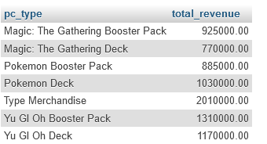

*-- 4 Show employee with the highest number of transaction services*

SELECT Employee.e_ID, Employee.e_name, COUNT(Transaction.t_ID) AS total_transaction

FROM Employee

JOIN Transaction ON Employee.e_ID = Transaction.t_e_ID

GROUP BY Employee.e_ID, Employee.e_name

ORDER BY total_transaction DESC

LIMIT 1;

Result:



*-- Nested Query*

*-- 1 Retrieve members with a total point above the average*

SELECT *

FROM membership

WHERE m_totalPoin > (SELECT AVG(m_totalPoin) FROM membership);

Result:



*-- 2 Ryu Liam's friend, Ian Harris, wants to pay his transaction here. In December, there is a 10% discount, so his transactions are subject to the discount. Display the total price he needs to pay for all his transa*

SELECT SUM(t_totalPrice * 0.9) AS totalTagihan FROM Transaction

WHERE t_p_ID = (

    SELECT p_ID FROM Player

    WHERE p_name = 'Ian Harris'

);

*ctions.*

Result:



*-- 3 Show the difference in income for November and October*

SELECT

    NovemberIncome,

    DecemberIncome,

    DecemberIncome - NovemberIncome AS IncomeDifference

FROM (

    SELECT

        SUM(t_totalPrice) AS NovemberIncome

    FROM

        `transaction`

    WHERE

        MONTH(t_date) = 11

) AS NovemberData,

(

    SELECT

        SUM(t_totalPrice) AS DecemberIncome

    FROM

        `transaction`

    WHERE

        MONTH(t_date) = 12

) AS DecemberData;

Result:



Thank You for Reading

&

Have a Good Day Ma’am 😊